Kubernetes 08

1️⃣ Create and Test a Kubernetes Pod with an EmptyDir Volume
Step 1: Create Pod YAML
vi emptydir.yaml
apiVersion: v1
kind: Pod
metadata:
name: emptydir-pod
spec:
containers:
- name: app
image: nginx
volumeMounts:
- mountPath: /data
name: cache-volume
volumes:
- name: cache-volume
emptyDir: {}
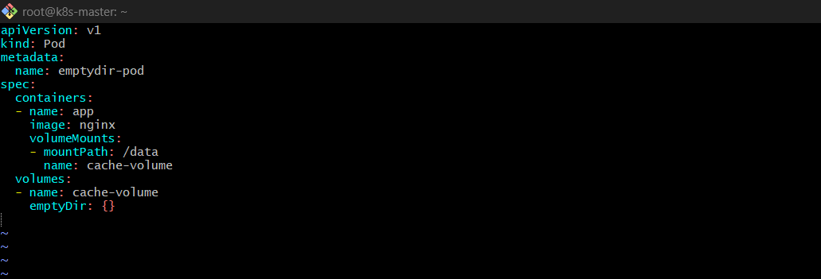
Apply it:
kubectl apply -f emptydir.yaml
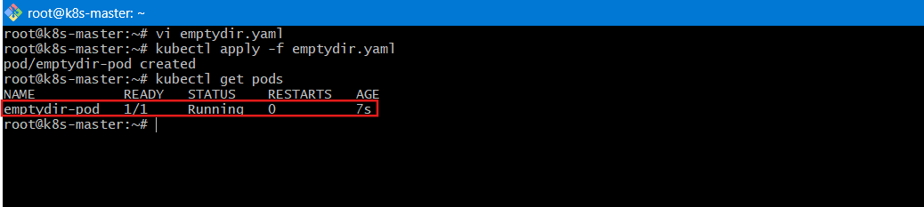
Step 2: Validate
Check pod status:
kubectl get pod emptydir-pod
Exec into pod:
kubectl exec -it emptydir-pod -- /bin/bash
Inside container:
echo "Hello EmptyDir" > /data/test.txt
cat /data/test.txt
You should see:
Hello EmptyDir
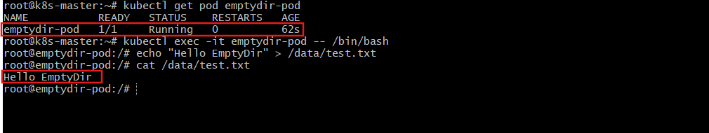
Step 3: Test Ephemeral Behavior
Delete pod:
kubectl delete pod emptydir-pod
Recreate it and check:
kubectl exec -it emptydir-pod -- cat /data/test.txt
❗ File will NOT exist (EmptyDir is deleted with pod).
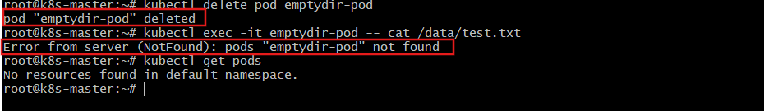

2️⃣ Configure a HostPath Volume in Kubernetes and Validate Data Persistence
Step 1: Create Pod YAML
vi hostpath.yaml
apiVersion: v1
kind: Pod
metadata:
name: hostpath-pod
spec:
containers:
- name: app
image: nginx
volumeMounts:
- mountPath: /host-data
name: host-volume
volumes:
- name: host-volume
hostPath:
path: /tmp/hostpath-data
type: DirectoryOrCreate
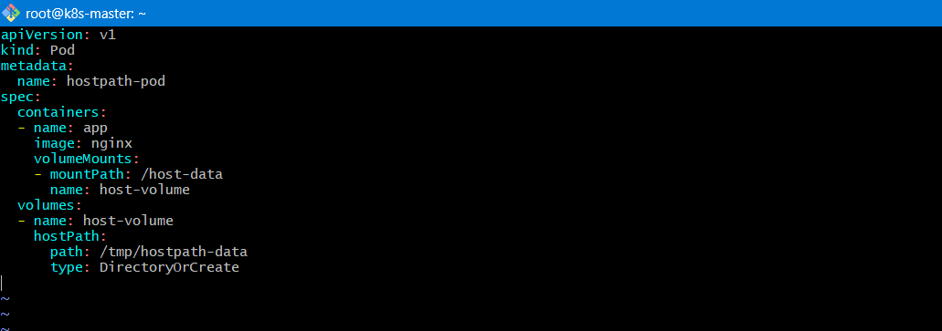
Apply:
kubectl apply -f hostpath.yaml
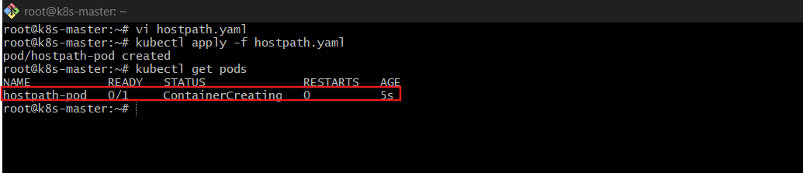
Step 2: Validate
Exec into pod:
kubectl exec -it hostpath-pod -- /bin/bash
Inside container:
echo "Persistent Data" > /host-data/test.txt
cat /host-data/test.txt
exit
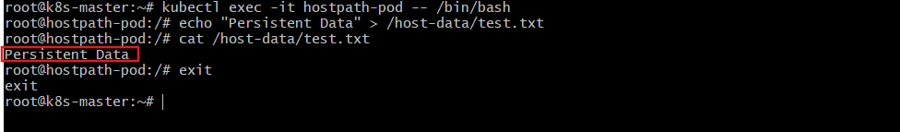
🔹 Step 3: Delete and Recreate Pod
kubectl delete pod hostpath-pod
kubectl apply -f hostpath.yaml
Check file again:
kubectl exec -it hostpath-pod -- cat /host-data/test.txt
✅ File still exists (stored on node filesystem).
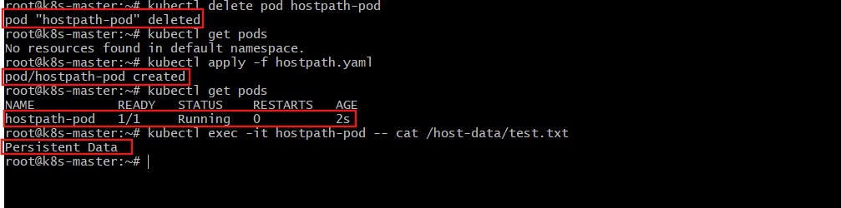

3️⃣ Deploy an Amazon EBS Volume Using Persistent Volume and Persistent Volume Claim (PVC)
This requires a cluster running in Amazon Web Services.

Step 1: Create EBS Volume
Create an EBS volume in Amazon Elastic Block Store
Note the Volume ID.
volume id: vol-03d1e006b44858599
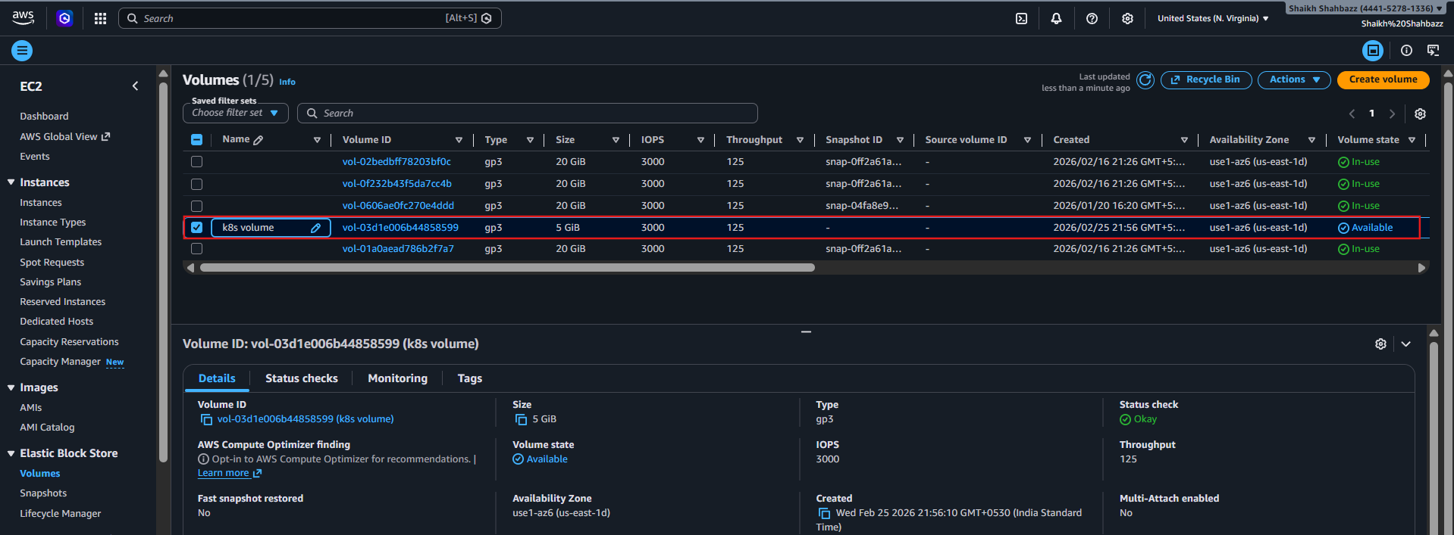
🔹 Step 2: Create Persistent Volume
vi pv.yaml
apiVersion: v1
kind: PersistentVolume
metadata:
name: ebs-pv
spec:
capacity:
storage: 5Gi
volumeMode: Filesystem
accessModes:
- ReadWriteOnce
awsElasticBlockStore:
volumeID: vol-03d1e006b44858599
fsType: ext4
persistentVolumeReclaimPolicy: Retain
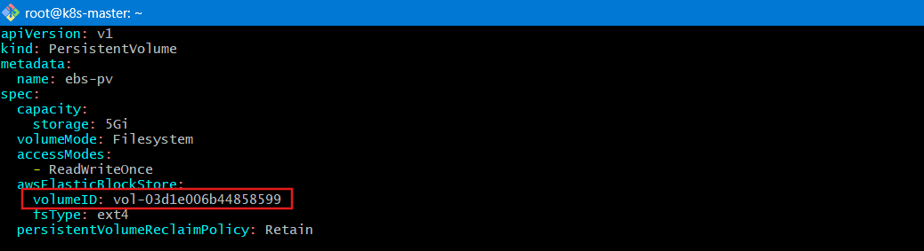
Apply:
kubectl apply -f pv.yaml
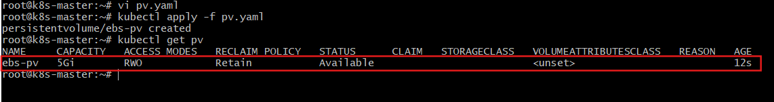
🔹 Step 3: Create PVC
vi pvc.yaml
apiVersion: v1
kind: PersistentVolumeClaim
metadata:
name: ebs-pvc
spec:
accessModes:
- ReadWriteOnce
resources:
requests:
storage: 5Gi
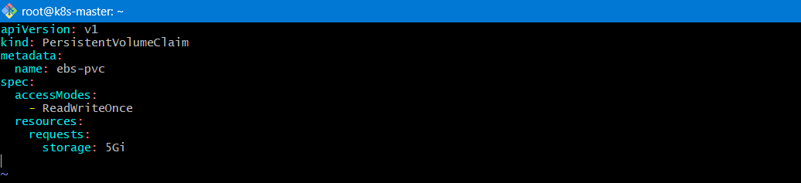
Apply:
kubectl apply -f pvc.yaml
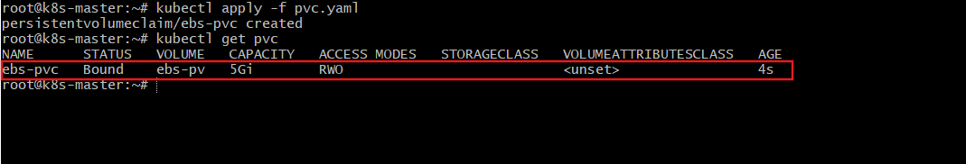
Check binding:
kubectl get pvc
kubectl get pv
Status should be Bound.
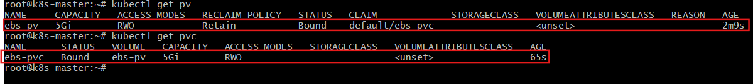
🔹 Step 4: Create Pod Using PVC
vi ebs-pod.yaml
apiVersion: v1
kind: Pod
metadata:
name: ebs-pod
spec:
containers:
- name: app
image: nginx
volumeMounts:
- mountPath: /data
name: ebs-storage
volumes:
- name: ebs-storage
persistentVolumeClaim:
claimName: ebs-pvc
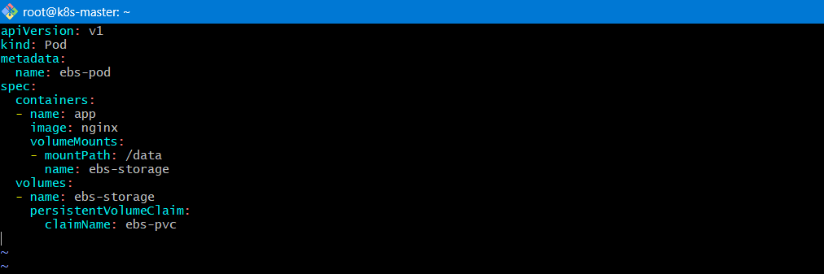
Apply:
kubectl apply -f ebs-pod.yaml
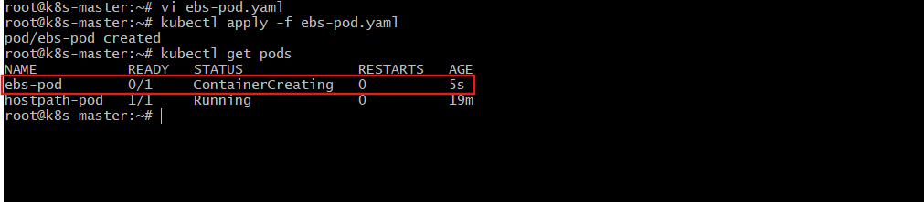
- Attach IAM Role to Worker Nodes
We need to give EC2 permission to manage EBS volumes.

Step 1: Create IAM Policy
AWS already provides managed policy:
AmazonEBSCSIDriverPolicy
You do NOT need to create custom policy.
It is provided by Amazon Web Services

Step 2: Create IAM Role for EC2
Go to:
AWS Console IAM Roles Create Role
Choose:
- Trusted entity type → AWS service
- Use case → EC2
Click Next.

🔹 Step 3: Attach Required Policies
Attach:
AmazonEBSCSIDriverPolicy
Also make sure your node role has:
AmazonEC2ContainerRegistryReadOnly
(Needed for pulling images)
Click Next → Name the role:
k8s-worker-ebs-role
Create role.
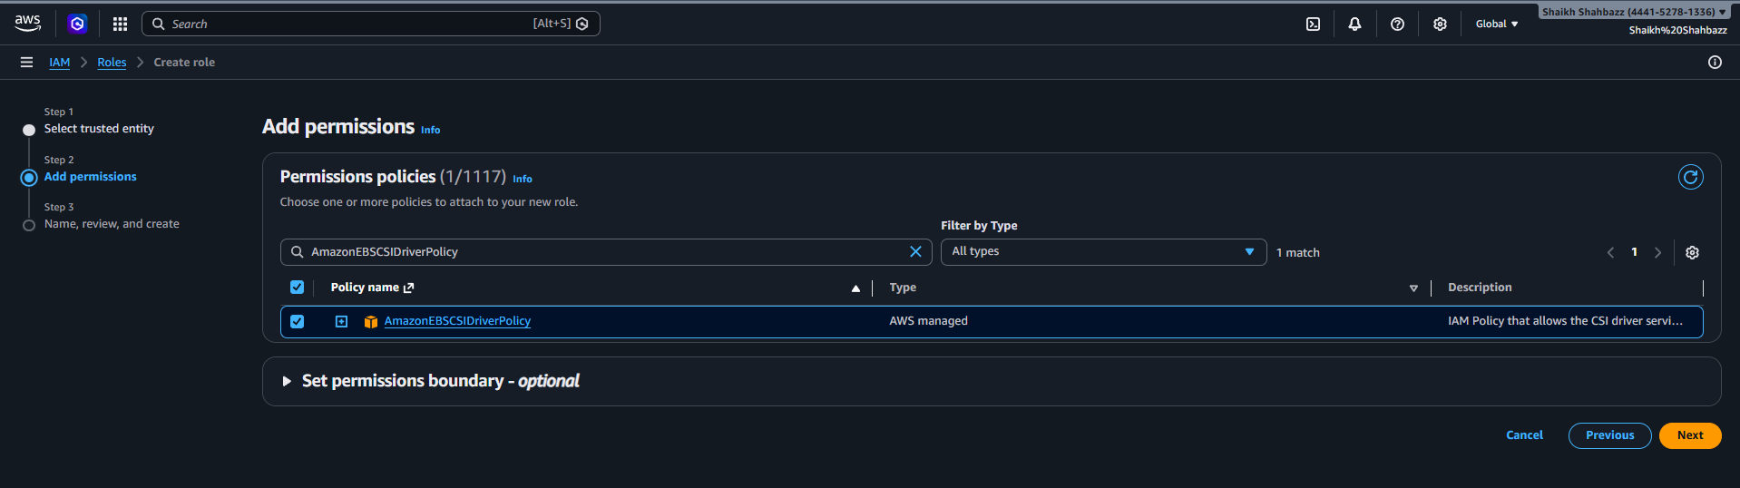
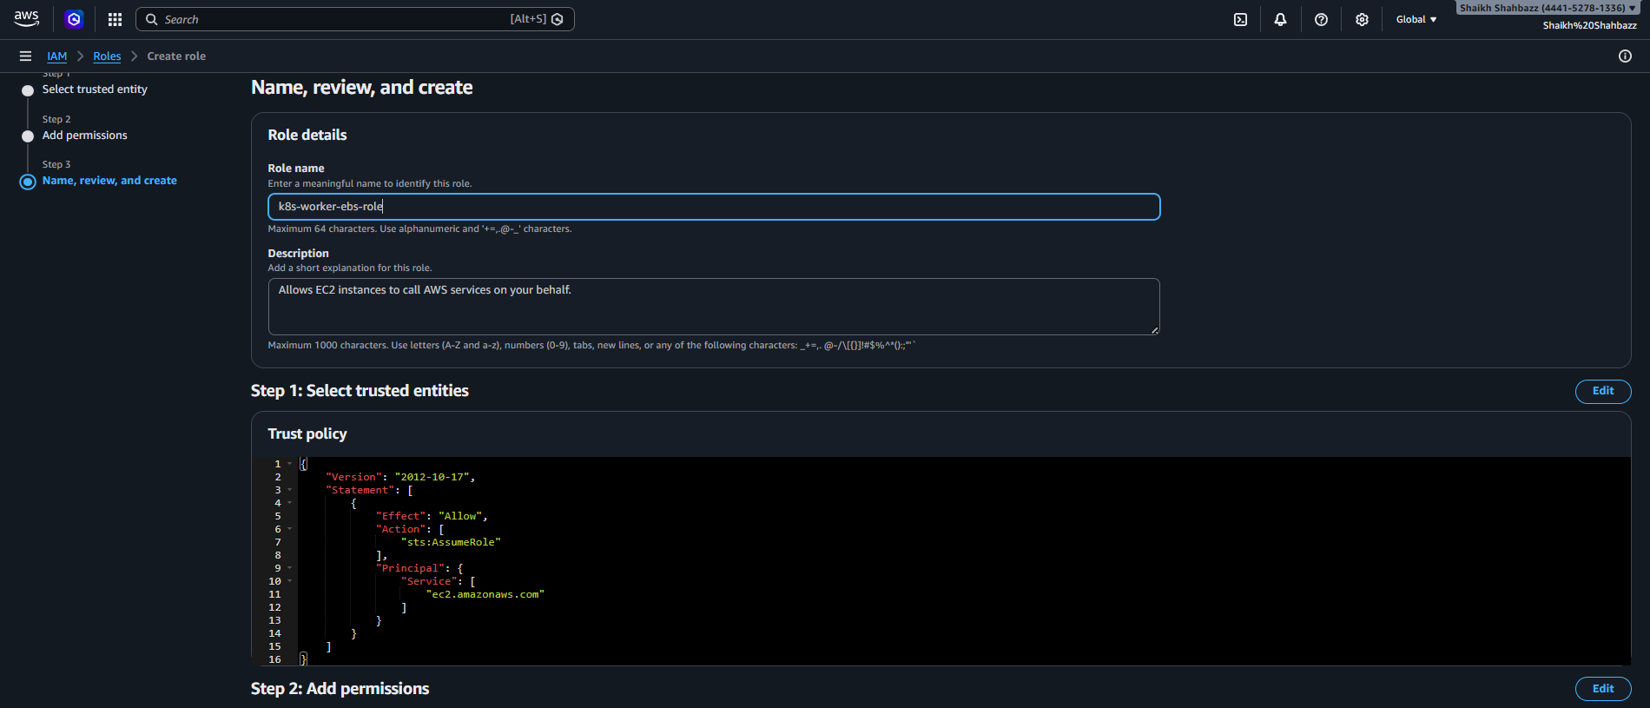
Step 4: Attach Role to Worker Nodes
Go to:
- EC2
- Instances
- Select worker nodes (example: worker01, worker02)
- Actions → Security → Modify IAM role
Attach:
k8s-worker-ebs-role
Save.
Wait 1–2 minutes.
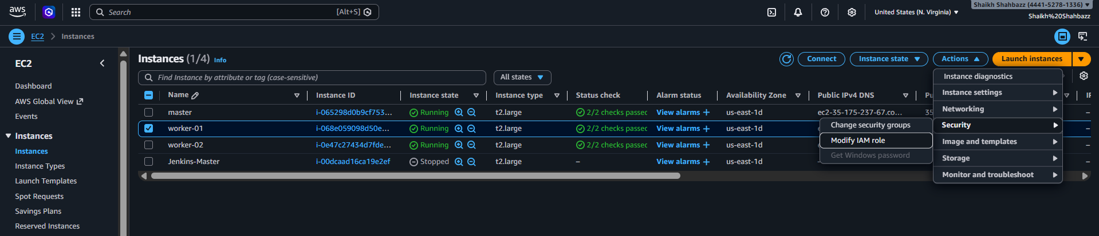
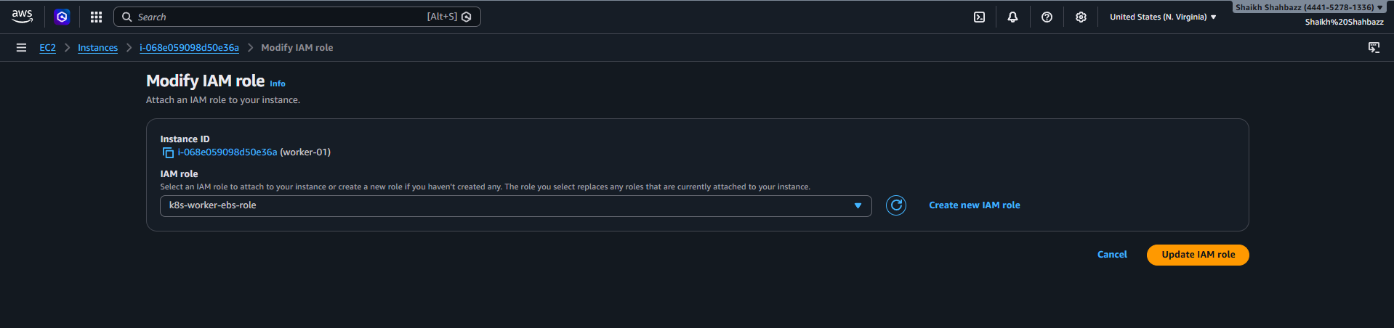
Install AWS EBS CSI Driver
Now install the driver inside Kubernetes.
Run:
kubectl apply -k "github.com/kubernetes-sigs/aws-ebs-csi-driver/deploy/kubernetes/overlays/stable/?ref=v1.29.0"
This installs:
- ebs-csi-controller
- ebs-csi-node
- RBAC configs
- CRDs
Official driver from Kubernetes SIGs
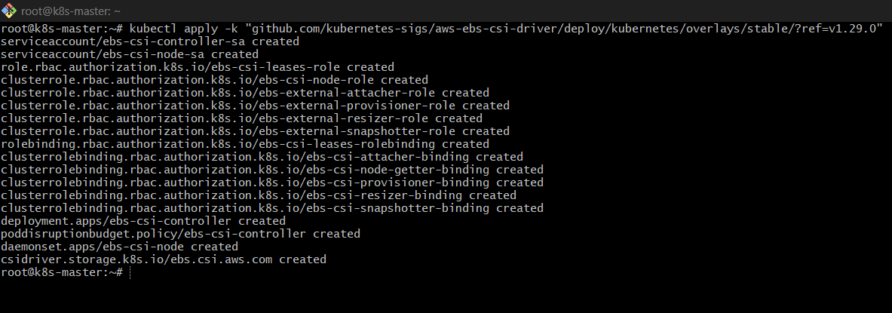
Verify Installation
kubectl get pods -n kube-system | grep ebs
You should see:
ebs-csi-controller-xxxxx Running
ebs-csi-node-xxxxx Running
Wait until ALL are Running.
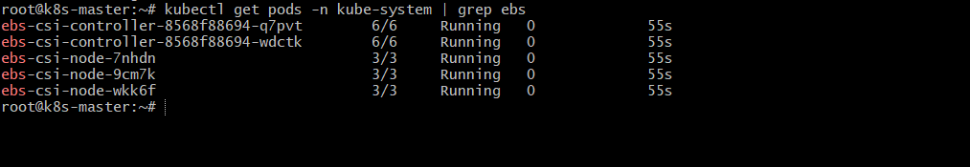
✅ Verify IAM Is Working
Now delete and recreate the pod:
kubectl delete pod ebs-pod
kubectl apply -f ebs-pod.yaml
kubectl get pods -w
Watch it.
If It Becomes Running
You're done

Step 5: Validation
Write file:
kubectl exec -it ebs-pod -- sh
echo "EBS Data" > /data/test.txt
exit
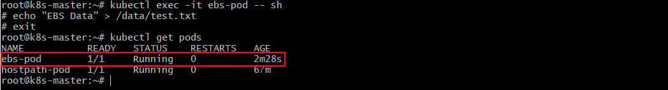
Delete pod:
kubectl delete pod ebs-pod
kubectl apply -f ebs-pod.yaml
Check file:
kubectl exec -it ebs-pod -- cat /data/test.txt
✅ File persists.
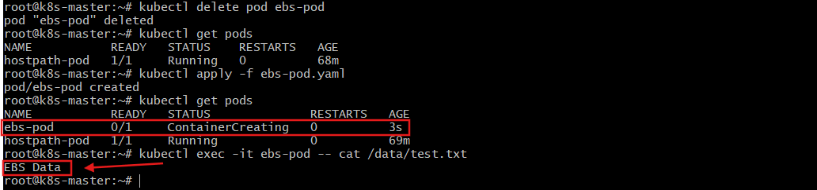

4️⃣ Set Up an Amazon EFS Volume and Attach it to Multiple Pods
Uses Amazon Elastic File System.

1 — Create Amazon EFS in AWS
Step 1: Create EFS File System
Go to:
- AWS Console
- EFS
- Create file system
- Select your VPC (same VPC as worker nodes)
- Keep default settings
- Create
After creation, note:
File System ID → fs-0386ffd9b03439523
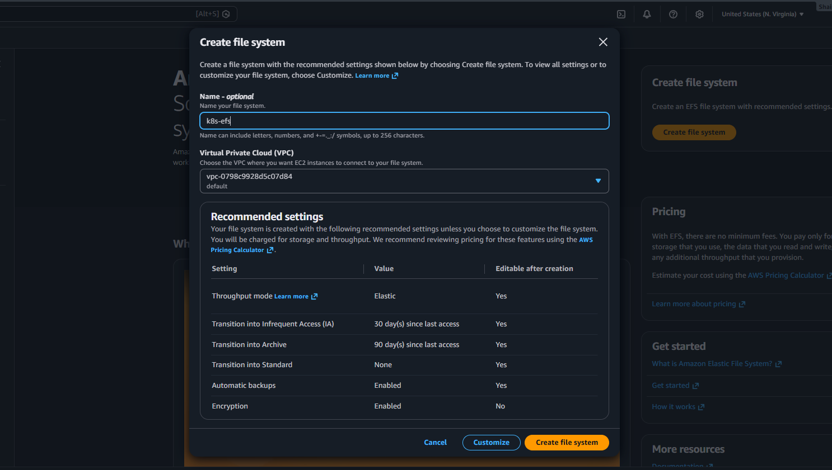
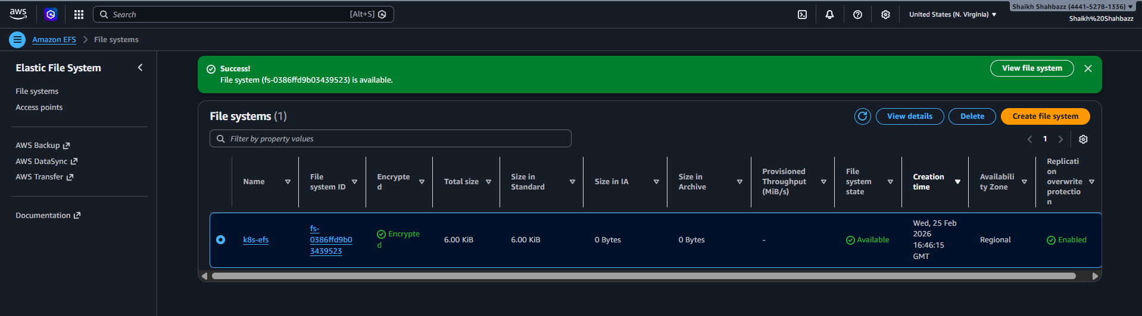
Step 2: Configure Security Group
Very Important
Go to:
EFS → Network → Manage security groups
Add inbound rule:
- Type: NFS
- Port: 2049
- Source: Worker node security group
This allows EC2 nodes to connect to EFS.
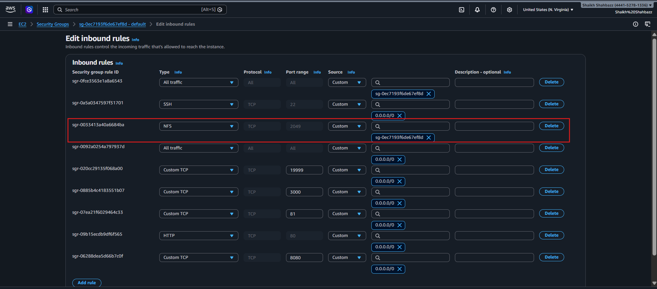
2 — Attach IAM Role to Worker Nodes
Your worker node IAM role must have:
AmazonEFSCSIDriverPolicy
If not:
IAM → Roles → Your worker role → Attach policy:
AmazonEFSCSIDriverPolicy
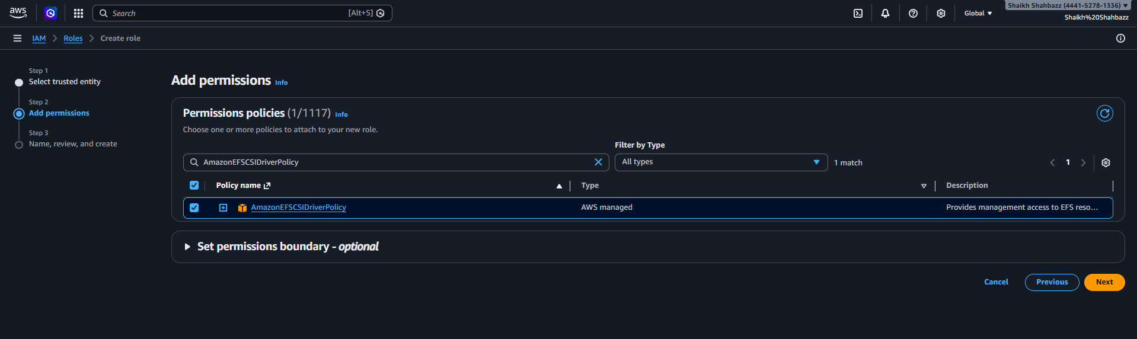
Attach the efs role to both worker nodes
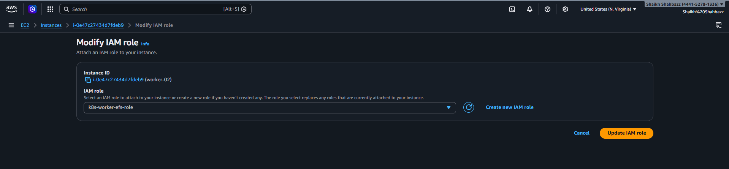
3 — Install AWS EFS CSI Driver
Install official driver:
kubectl apply -k "github.com/kubernetes-sigs/aws-efs-csi-driver/deploy/kubernetes/overlays/stable/?ref=master"
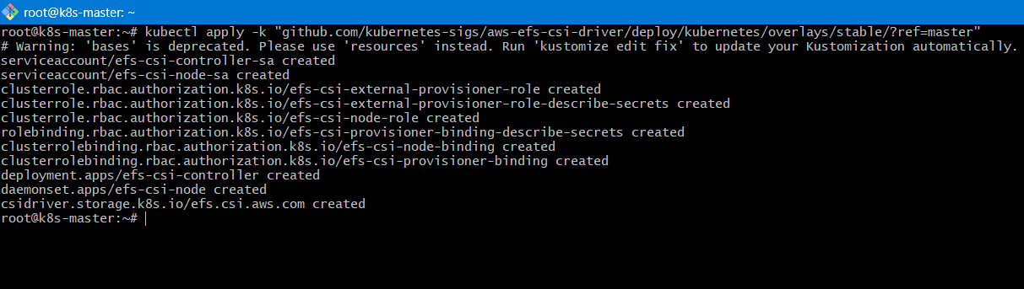
Official driver from Kubernetes SIGs
Verify:
kubectl get pods -n kube-system | grep efs
You should see:
efs-csi-controller-xxxxx Running
efs-csi-node-xxxxx Running
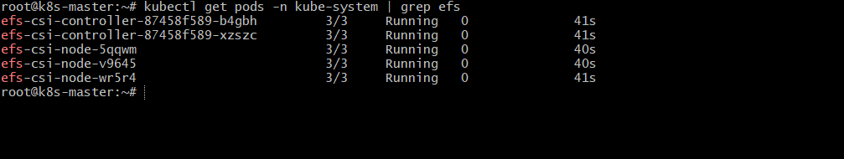
4 — Create StorageClass
Create file: efs-sc.yaml
vi efs-sc.yaml
apiVersion: storage.k8s.io/v1
kind: StorageClass
metadata:
name: efs-sc
provisioner: efs.csi.aws.com
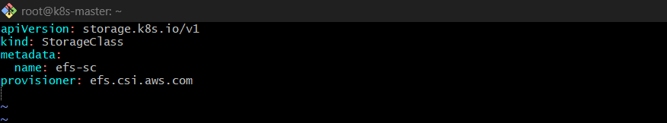
Apply:
kubectl apply -f efs-sc.yaml
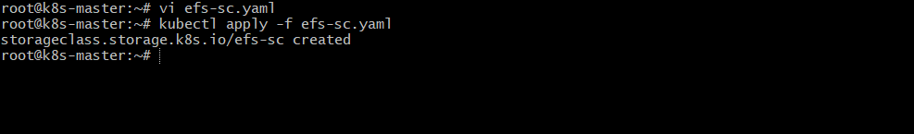
5 — Create PersistentVolume (Static Method)
Create efs-pv.yaml
Replace fs-0386ffd9b03439523 with your EFS ID.
vi efs-pv.yaml
apiVersion: v1
kind: PersistentVolume
metadata:
name: efs-pv
spec:
capacity:
storage: 5Gi
volumeMode: Filesystem
accessModes:
- ReadWriteMany
persistentVolumeReclaimPolicy: Retain
storageClassName: efs-sc
csi:
driver: efs.csi.aws.com
volumeHandle: fs-0386ffd9b03439523
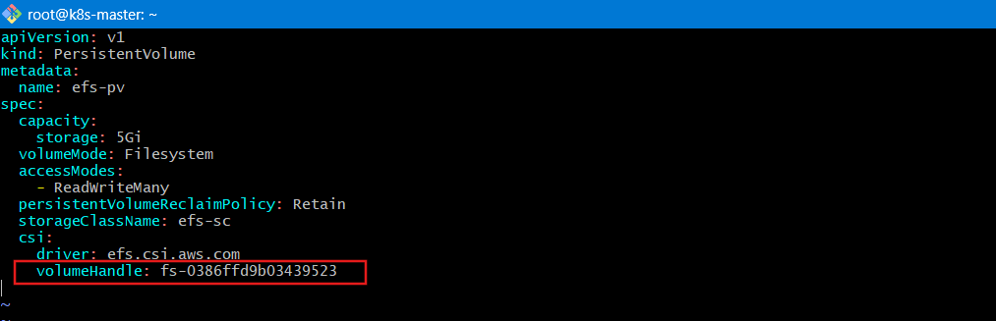
Apply:
kubectl apply -f efs-pv.yaml
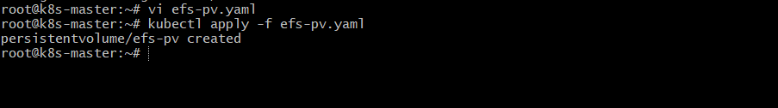
6 — Create PVC
Create efs-pvc.yaml
vi efs-pvc.yaml
apiVersion: v1
kind: PersistentVolumeClaim
metadata:
name: efs-pvc
spec:
accessModes:
- ReadWriteMany
storageClassName: efs-sc
resources:
requests:
storage: 5Gi
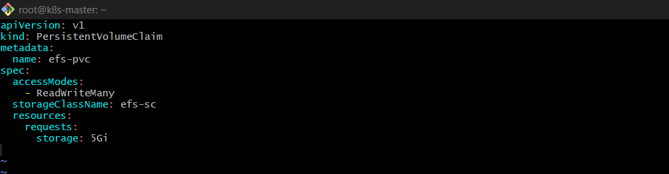
Apply:
kubectl apply -f efs-pvc.yaml
Check:
kubectl get pvc
Status must be:
Bound
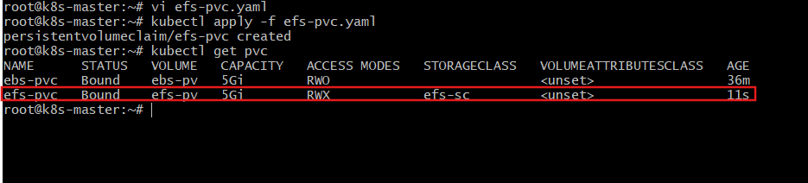
7 — Create Multiple Pods Using Same PVC
Create efs-pods.yaml
vi efs-pods.yaml
apiVersion: v1
kind: Pod
metadata:
name: efs-pod-1
spec:
containers:
- name: app
image: nginx
volumeMounts:
- mountPath: "/data"
name: efs-storage
volumes:
- name: efs-storage
persistentVolumeClaim:
claimName: efs-pvc
---
apiVersion: v1
kind: Pod
metadata:
name: efs-pod-2
spec:
containers:
- name: app
image: nginx
volumeMounts:
- mountPath: "/data"
name: efs-storage
volumes:
- name: efs-storage
persistentVolumeClaim:
claimName: efs-pvc
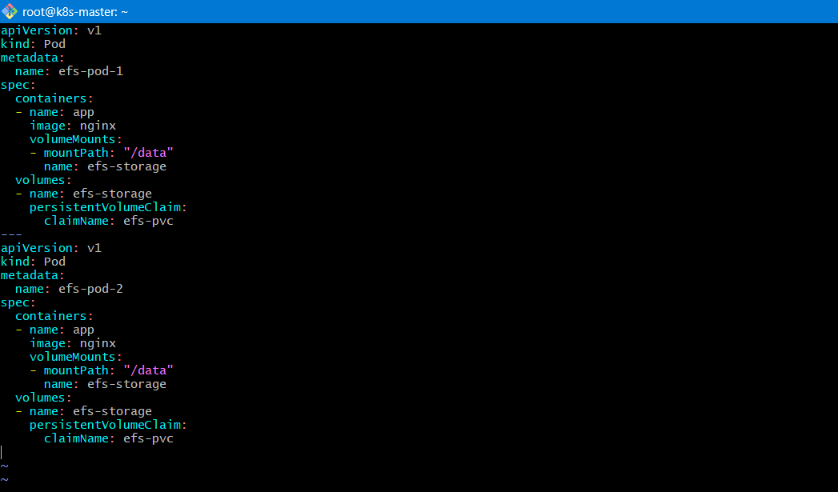
Apply:
kubectl apply -f efs-pods.yaml
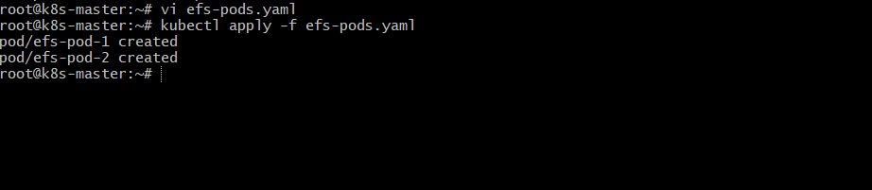
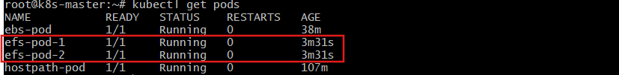
8 — Test Shared Storage
Exec into pod 1:
kubectl exec -it efs-pod-1 -- sh
Create file:
echo "Hello from Pod1" > /data/test.txt
exit.
Now check in pod 2:
kubectl exec -it efs-pod-2 -- sh
cat /data/test.txt
You will see:
Hello from Pod1
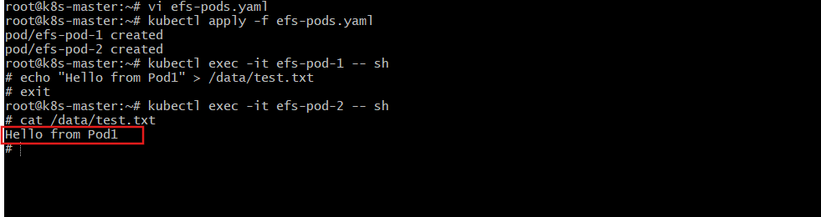
5️⃣ Implement and Test Liveness and Readiness Probes in a Kubernetes Pod
Step 1: Create Pod YAML
vi probe.yaml
apiVersion: v1
kind: Pod
metadata:
name: probe-pod
spec:
containers:
- name: app
image: nginx
ports:
- containerPort: 80
livenessProbe:
httpGet:
path: /
port: 80
initialDelaySeconds: 5
periodSeconds: 5
readinessProbe:
httpGet:
path: /
port: 80
initialDelaySeconds: 5
periodSeconds: 5
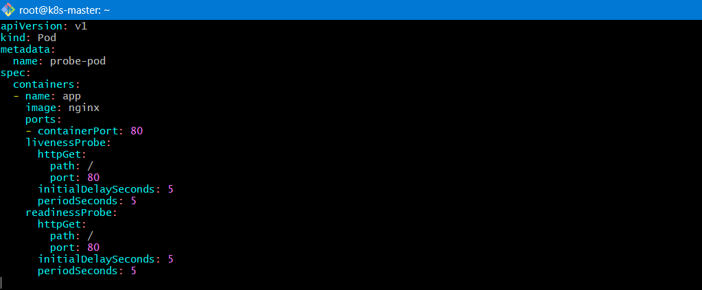
Apply:
kubectl apply -f probe.yaml

Step 2: Validate Readiness
kubectl get pod probe-pod
You should see:
1/1 READY
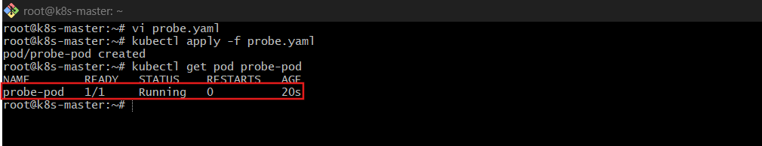
Step 3: Test Liveness Failure
Exec into pod:
kubectl exec -it probe-pod -- /bin/bash
Stop nginx:
nginx -s stop
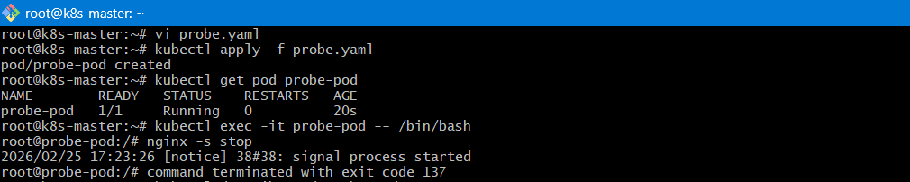
Exit and check:
kubectl describe pod probe-pod
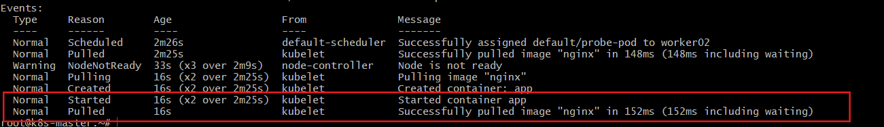
You will see:
Liveness probe failed
Pod will automatically restart.
Check restart count:
kubectl get pod probe-pod
Restart count increases ✅

